17. **PREDICTION OF CATEGORICAL DATA USING BAYESIAN ALGORITHM USING WEKA**

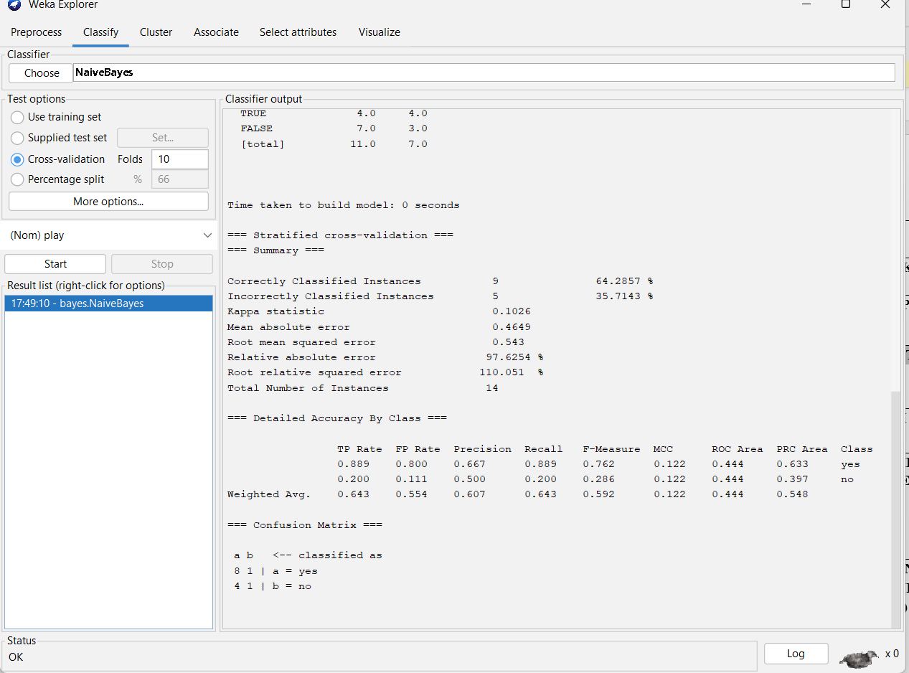

OUTPUT INFORMATION WEATHER NUMERIC BASED ON NAVIES BAYES RULE..